1) What is software? What is software engineering?

* Software: Software is the language of computer. In simple terms, software is set of instruction written in programming language which orders computer to do various tasks. Also, there are three main types of software.

1. System software / Operating system
2. Application software
3. Programming

* Software engineering (S.E.): S.E. is the systematic and disciplined approach to designing, developing, testing, and maintaining software. It represents the principle from Mathematics, computer science and project management to create user friendly software products.

**2) Explain types of software: -**

* There are three types of Software.

1. System software / Operating software: The operating system is the core software that manages computer hardware and provides services for computer programs. It acts as an intermediary between the user and the hardware.

ex: - Windows, Linux, Android

1. Application software: The most common type of software, application software is a computer software package that performs a specific function for a user, or in some cases, for another application. - An application can be self-contained, or it can be a group of programs that run the application for the user. - Examples of Modern Applications include office suites, graphics software, databases and database management programs, web browsers, word processors, software development tools, image editors and communication platforms.
2. Middleware: Middleware acts as a bridge between different software applications or components, facilitating communication and data exchange. Examples include database management systems, application servers, and message brokers.
3. Programming software: This type of software is used by developers to create, debug, and maintain other software. Common examples are Integrated Development Environments (IDEs) like Visual Studio, Eclipse, and JetBrains IDEs.
4. Driver software: This software is part of System software and known as Also known as device drivers. Even, it is acts as a bridge between the operating system and hardware devices connected to a computer. Also, every device that is connected to a computer needs at least one device driver to function. Examples include software that comes with any nonstandard hardware, including special game controllers, as well as the software that enables standard hardware, such as USB storage devices, keyboards, headphones and printers.

3) What is SDLC? Explain each phase of SDLC: -

* The full form of SDLC is Software Development Life Cycle which refers to a methodology with clearly defined processes for creating high-quality software.
* These methodology focuses on 6 phases: -

1. Requirement Gathering: This initial phase involves gathering and understanding the requirements of the software to be developed. It includes meetings with stakeholders, users, and clients to identify their needs and expectations. The goal is to create a detailed and comprehensive list of functional and non-functional requirements that the software should meet.
2. Analysis: The analysis phase defines the requirements of the system, independent of how these Requirements will be accomplished. This phase defines the problem that the customer is trying to solve. The deliverable result at the end of this phase is a requirement document.
3. Designing: In this phase, the software design is created, which includes the overall architecture of the software, data structures, and interfaces. It has two steps
4. Implementation: The design is then implemented in code, usually in several iterations, and this phase is also called as Development.

things you need to know about this phase:

* This is the longest phase in SDLC model.
* This phase consists of Front end + Middleware + Back-end.
* In front-end: Development of coding is done even SEO settings are done.
* In Middleware: They connect both the front end and back end.
* In the back-end: A database is created.

1. Testing: The software is thoroughly tested to ensure that it meets the requirements and works correctly.
2. Maintenance: This phase includes ongoing support, bug fixes, and updates to the software.
3. What is DFD? Create a DFD diagram on Flipkart:

DFD stands for "Data Flow Diagram." It is a graphical representation that depicts the flow of data within a system or process. DFDs are commonly used in software engineering, systems analysis, and business process modelling to visualize how data moves from one component to another within a system.

In a Data Flow Diagram, data flows are represented as arrows, and the different components of the system (e.g., processes, data stores, external entities) are represented as circles or rectangles. There are four main components and their symbols in a DFD:

1. Process: The process shape is represented by a rectangle with rounded corners. It represents an activity or function that manipulates the data within the system. Processes are where data is transformed or processed.
2. Data Flow: The data flow shape is represented by an arrow. It shows the movement of data from one process to another or between processes, data stores, and external entities. The arrow's direction indicates the flow of data.

1. Data Store: The data store shape is represented by two parallel lines. It represents a repository where data is stored within the system. Data stores can be databases, files, or any other storage location.
2. External Entity: An external entity represents sources or destinations of data that are outside the scope of the system. These entities interact with the system but are not part of it.

External Entity

**Data flow on Flipkart:**

Admin

**Request**

**For Response**

**Login**

Request

**For Response**

**Registration**

user

5) What is Flow chart? Create a flowchart to make addition of two numbers.

* A flow chart is a graphical or symbolic representation of a process. Each step in the process is represented by a different symbol and contains a short description of the process step. The flow chart symbols are linked together with arrows showing the process flow direction.
* The addition of two number:

END

Print SUM

SUM = A + B

Input A,B

Start

6) What is Use case Diagram? Create a use-case on bill payment on Paytm.

* A use case diagram is a way to summarize details of a system and the users within that system. It is generally shown as a graphic depiction of interactions among different elements in a system.
* 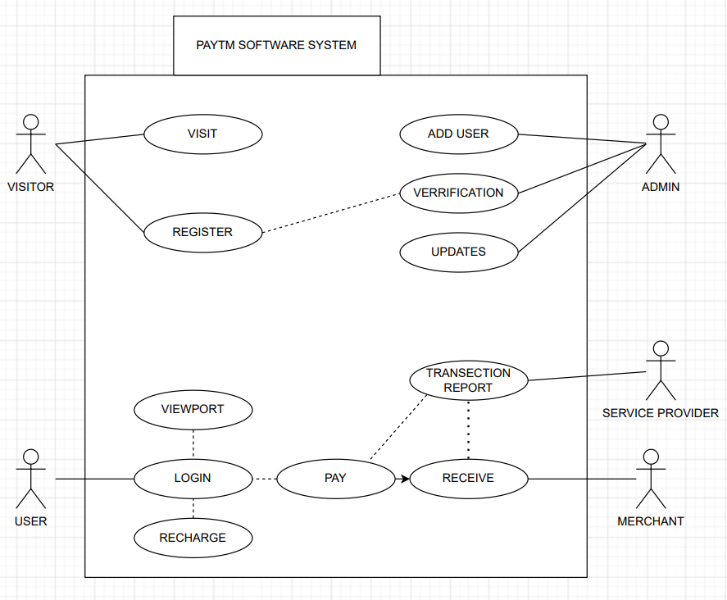Use-case diagrams illustrate and define the context and requirements of either an entire system or the important parts of the system. You can model a complex system with a single use-case diagram, or create many use-case diagrams to model the components of the system. You would typically develop use-case diagrams in the early phases of a project and refer to them throughout the development process.